- Explain lazy evaluation in PySpark.

In Spark , when we are doing transformations, Spark does not execute them immediately. Instead, it builds a logical execution plan that represents the sequence of transformations. This plan is executed only when an action is invoked.

To improve performance, Reducing unnecessary actions and trigger only Fewer actions. This allows Spark to optimize the execution plan, reduce data shuffling and Allows faster execution.
🧠 Example:
df = spark.read.csv("data.csv", header=True)
filtered_df = df.filter(df["age"] > 30) --- --- still no execution has happened yet
selected_df.show() # <-- Only here the transformations are executed!
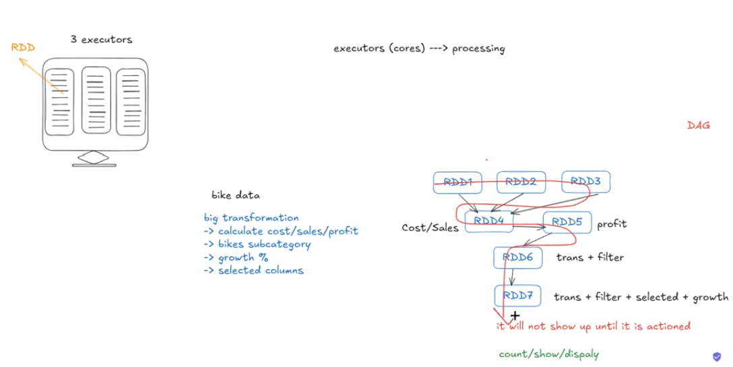

File formats :

I have worked with multiple file formats in Spark and PySpark, mainly CSV, JSON, Parquet, and Delta.
- CSV – Used to load raw data . It is easy to read but not efficient for big data processing.
- JSON – Used for semi-structured data, from APIs and logs.
- Parquet – A columnar file format , efficient for Spark workloads.
- Delta Lake – It supports ACID transactions, schema evolution, and time travel, and is commonly used in Databricks.

- Explain the difference between narrow and wide transformations in PySpark?
Narrow transformation means output partition depends on only one input partition. There is no data movement (no shuffle) across nodes, transformation happens within the same stage and is faster Operation.
Examples: map, filter, withColumn , select
A wide transformation means output partition depends on multiple input partitions. This requires data shuffling across nodes, which creates a new stages for Transformations . So operation Become slower compared to narrow transformations.
Examples: groupBy, reduceByKey, joins
So, whenever the transformation involves multiple RDDs, or the data has to be moved from one RDD to another RDD, in that case we go with wide transformation. And narrow transformation is like, if you are doing a transformation without a data movement, in that case you can go with a narrow transformation.
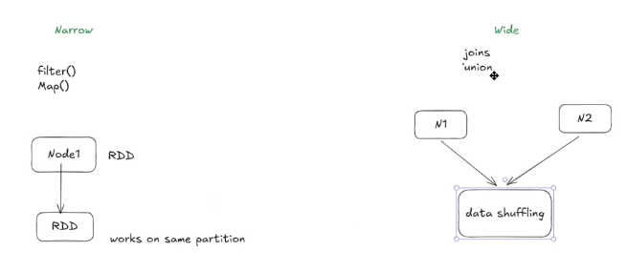

- Explain broadcast join in PySpark?
A broadcast join is an optimization technique used to improve join performance in PySpark. If we join large datasets data shuffling will happen.
When one dataset is small, Spark broadcasts the small dataset to all worker nodes. Then Each node joins with large dataset locally(in memory) , avoiding shuffle operations.
This reduces data shuffling and improves performance. Spark decides broadcast joins based on the AutoBroadcastJoinThreshold (default ~10 MB) . we can Broadcast only small Datasets, if we Broadcast large datasets memory issues will come.

RDD:
RDD will be small small units where we can store the data.
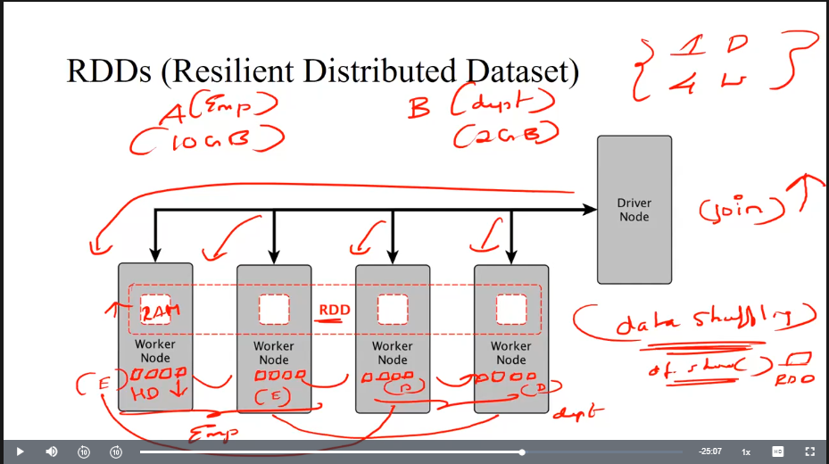
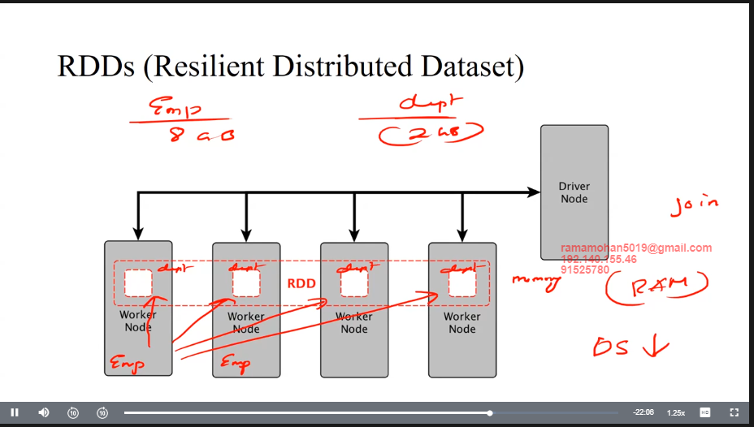
- Explain broadcast variables in PySpark?
Spark sends a copy of that variable to every task, unnecessary data transfer.
Broadcast variables are used to share small, read-only data across all executors. Spark sends the broadcast variable once to each executor and stores it in memory, so all tasks can reuse it without repeated data transfer. This reduces data transfer and improves performance..
Here data shuffling is involved, data moves one node another node: reduced the performance to overcome this we store the data in RAM.
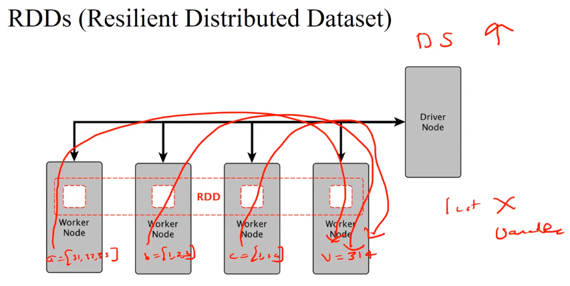

To Improve this: we will store the variable value in RAM, Here data shuffling is lesser, the reason, the interaction between the disk and RAM there is no much of data shuffling involved. Data is not moved from one network to another network or one node to another node. Directly we can access the value over the memory, that’ why improving. This is called broadcast variables.

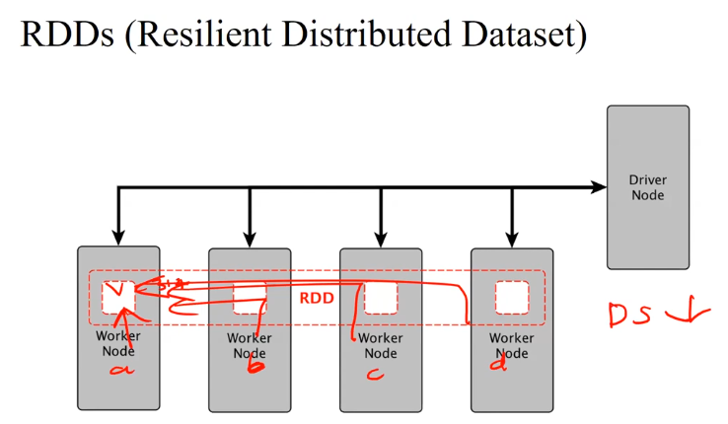

- Difference between repartition and coalesce in PySpark?
Both are used to control the number of partitions in RDD or DataFrame.
Repartition is used to increase or decrease the number of partitions. It performs a full shuffle. Because of the shuffle, it is more expensive and Slow .it can process multiple partitions.
Coalesce is used to Decrease the number of partitions. It merges existing partitions without a full shuffle, it is faster and more efficient.
Repartition is preferred when increasing partitions or balancing data. coalesce is preferred when reducing partitions, especially before writing output.

You say coalesce is better, but are you going to stop using repartition, is repartition not at all used?
If I want to increase the number of partitions, I have to use repartition — coalesce will not work in that case. Both have their own pros and cons.
Repartition:
Increase partition or descrease partition
Data shuffling takes place
Performance will go down
Costly operation (because of data shuffling)
Coalesce :
Only decrease the partition is possible
Data shuffling is very minimal
Performance will be faster
Cheap(because of less data shuffling)

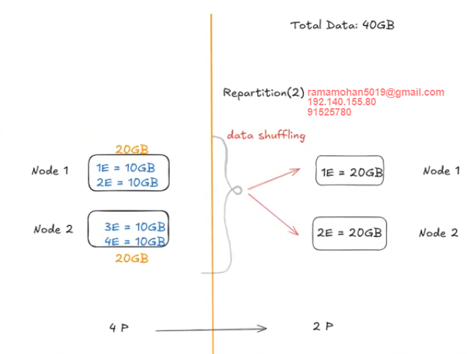

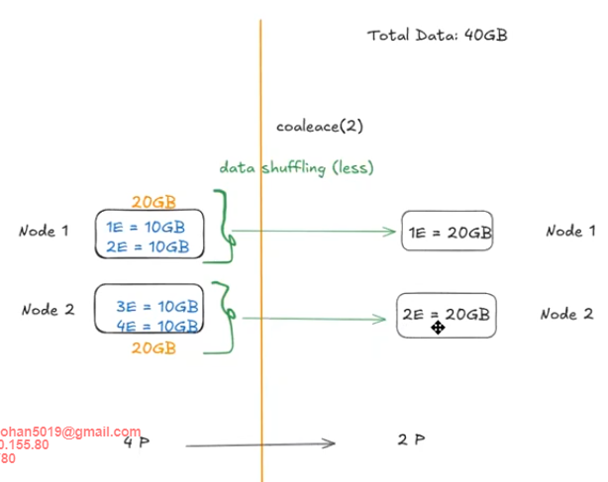
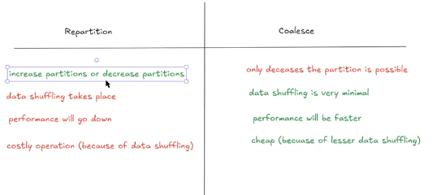
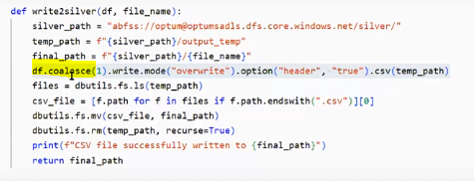
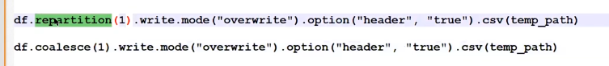

- Explain Adaptive Query Execution (AQE) in Spark.

Adaptive Query Execution – changes the execution plan at runtime Based on actual data statistics instead of Depending on static estimations.

Using AQE, Spark can dynamically change join strategies, shuffle partitions, and handle skewed data while the query is executing.

For example, Spark Doing shuffle join, but at runtime it detects one table is small, AQE automatically switches to a broadcast join. It also reduces the number of shuffle partitions , avoid slow tasks.
Spark changing its execution plan while the query is running

🔑 Key Points to Tell in Interview:
- Runtime Optimization: AQE adjusts the query plan during execution, rather than relying only on the static plan created at compile time.
- Handles Skew and Cardinality: It deals with data skew, wrong estimations, and dynamic join strategies more effectively than traditional optimizers.
- Improves Performance: Helps improve query speed and stability, especially for large or unpredictable datasets.
- Join Strategy Switching: AQE can dynamically switch between sort-merge join, shuffle hash join, or broadcast join depending on the data sizes encountered at runtime.
- Partition Coalescing: It can merge small shuffle partitions at runtime to avoid having too many small tasks, which improves efficiency.
- Skew Join Handling: Automatically detects skewed partitions and handles them by splitting large partitions into smaller ones.

# Enable Adaptive Query Execution
spark.conf.set("spark.sql.adaptive.enabled", "true")
spark.conf.set("spark.sql.adaptive.coalescePartitions.enabled", "true")
spark.conf.set("spark.sql.adaptive.skewJoin.enabled", "true")

- Difference between groupByKey and reduceByKey in PySpark.
Both are used to group data by key in Spark.
(A, 10) (A, 20) (B, 5) (B, 15)
GroupByKey Sends all values To each key and shuffles them across the network before aggregations. This leads to high data shuffling and high memory usage.
Partition 1: (A,10), (A,20) → (A,30)
ReduceByKey , performs local aggregation on each partition before the shuffle. Only the reduced results are sent across the network, It reduces shuffle size and improves performance.
Hence, whenever aggregation is required, reduceByKey is preferred over groupByKey for better efficiency and scalability.

Note:
Mapper: Mapper actually split the data.
Reducer: what it will do, after doing all the calculations it will club it, may be I can put it as aggregate it.
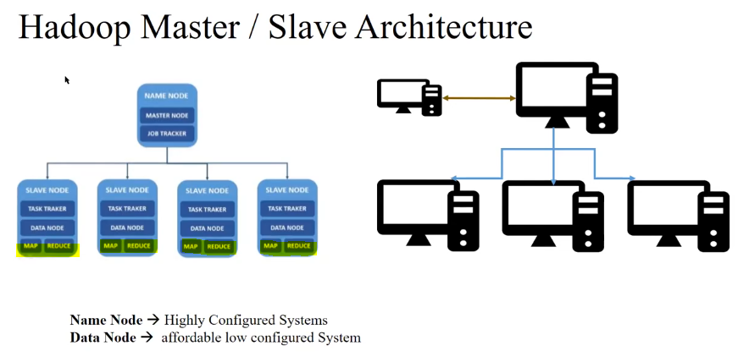
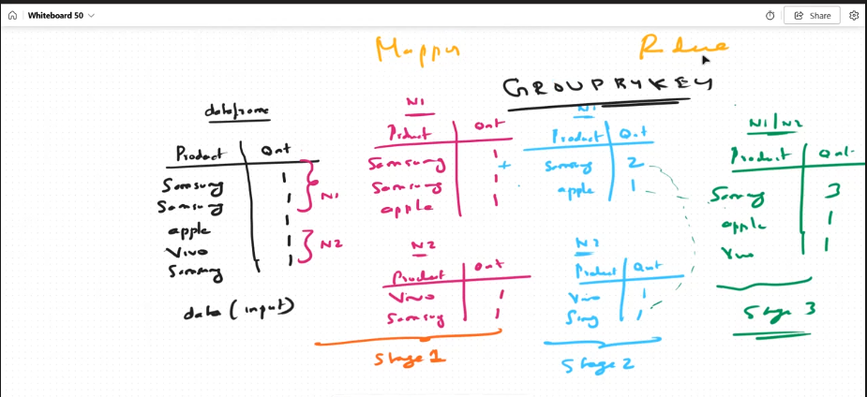
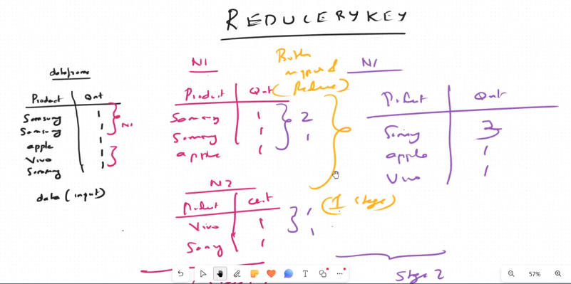
Executors are nothing but collection of cores
RDD’s are nothing but storages, they will store the data
- How to cache and persist data in PySpark?
Cache() stores a DataFrame or RDD in memory and is mainly used when the same data is reused multiple times. Internally, cache() is the same as persist(MEMORY_ONLY). If the data does not fit in memory, Spark re-compute ( re- executes ) the missing partitions.
Persist() provides more control over storage by allowing data to be stored in MEMORY_ONLY or DISK_ONLY, or BOTH. For large datasets, MEMORY_AND_DISK is preferred because it keeps data in memory when possible and spills excess data to disk, avoiding recomputation.
In short, Cache() is suitable for small datasets that fit in memory, Persist() is better for large datasets requiring flexible storage.

MEMORY_ONLY: The data is stored in memory only. This is the fastest storage level, but it is also the least durable. But if the data is large and couldn't fit in memory than it will calculated on runtime
DISK_ONLY: The data is stored on disk only. This is the most durable storage level, but it is also the slowest.
MEMORY_AND_DISK: The data is stored in memory and once memory full it will spill the rest on disk. This is a good compromise between performance and durability.
So, to summarize:
- Use cache() for smaller datasets that comfortably fit in memory.
- Use persist() when you need more storage flexibility for larger datasets.
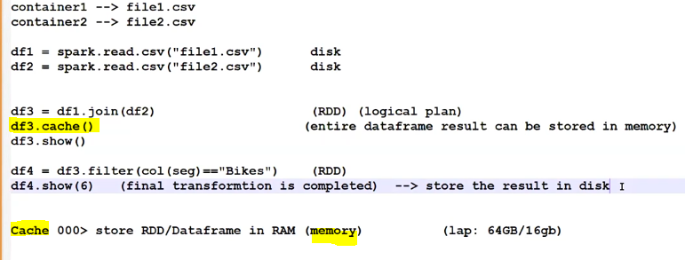
- Difference between RDD vs Dataframe vs Datasets?
RDD is the lowest-level abstraction and works with unstructured data without a schema, giving full control but limited optimization and slower performance.
DataFrames are a higher-level, structured API where Spark knows the schema and applies Catalyst and Tungsten optimizations, making them faster and easier to use.
Datasets are mid-level , extend DataFrames by adding compile-time type safety and are mainly used in Scala or Java.
RDD is the lowest-level abstraction in Spark and works with unstructured data without any schema. Since Spark does not have information about the data structure, it cannot apply automatic optimizations, giving the developer full control but resulting in slower performance.
DataFrames are a high-level abstraction that works with structured data in the form of rows and columns. Because Spark knows the schema, it applies Catalyst and Tungsten optimizations, making DataFrames faster and the most commonly used API in Spark applications.
Datasets are a strongly typed extension of DataFrames that provide compile-time type safety. They are mainly supported in Scala and Java and are rarely used in PySpark-based projects.
Feature | RDD | DataFrame | Dataset
Abstraction | Low-level | High-level | Medium-level
Structure | No | Yes (Rows & Columns) | Yes (Strongly Typed)
Performance | Lower | High (Optimized) | High (Optimized + Typed)
Language | All (Java, Scala, Python) | All | Scala and Java only
Use case | Custom logic, logs, text parsing | Structured data, SQL queries | Type-safe structured data in Scala

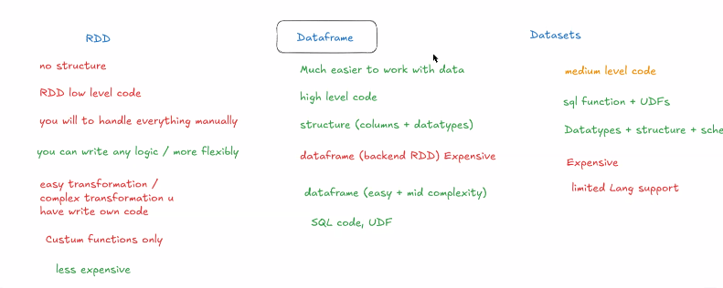
- Spark optimization?
Spark optimization means reducing execution time , data shuffling, and improving query execution.
I optimize joins by using broadcast joins when one table is small, which avoids shuffle and improves performance.
For aggregations, I prefer reduceByKey performs map-side aggregation and reduces data shuffled across the network.
I use cache or persist for DataFrames that are reused multiple times to avoid recomputation.
To manage partitions, I use coalesce to reduce partitions without shuffle when writing output, and repartition only when redistribution is required.
Finally, I use efficient file formats like Parquet or Delta, which support column pruning, predicate pushdown, and compression, further improving performance.
- What is Z-ordering in Spark?
Partiton 1 – ( 100-200 ) , Partition 2 – (200-300 )
Z-ordering – Organizing the data To keep similar values together, Then Skip irrelevant files and run queries faster.
Spark skip unnecessary files during query execution because Delta Lake stores min and max Statistics for each file. So The Spark reads only the related files instead of scanning the entire table.
Z-ordering is used on large Delta tables with frequent filters or joins, as it reduces data scanned and improves query performance.”
.

Example
OPTIMIZE sales
ZORDER BY (customer_id, order_date);
This reorganizes the data files so queries filtering by customer_id or order_date are
much faster.

- How to handle null values in PySpark (drop/fill)?
A In PySpark, null values can be handled using dropna() to drop rows with nulls and fillna() to replace them with specific values.

✅ 1. Dropping Null Values:
- Removes a row if at least one column is null
df_clean = df.dropna()
- Removes a row if specific column is null
df_clean = df.dropna(subset=["column1", "column2"])
- Remove row only when every column is null
df_clean = df.dropna(how="all")
- Drop if a row has less than a minimum number of non-null values:
df_clean = df.dropna(thresh=2) # Keeps rows with at least 2 non-null values

✅ 2. Filling Null Values:
- Fill all nulls with a constant value:
df_filled = df.fillna("unknown")
- Fill nulls with different values per column:
df_filled = df.fillna({"age": 0, "name": "N/A"})
- Fill numeric columns with average or median (custom logic):
from pyspark.sql.functions import avg

avg_value = df.select(avg("age")).first()[0]
df_filled = df.fillna({"age": avg_value})

- Write PySpark code for below requirement?

from pyspark.sql import SparkSession
from pyspark.sql.functions import avg

# Create Spark session
spark = SparkSession.builder.appName("JSON_Cleaning").getOrCreate()
- Reads a JSON file
df = spark.read.json("/path/input/employees.json")
- Removes rows with null values
df_clean = df.dropna()
- Calculates the average salary
avg_salary = df_clean.select(avg("salary").alias("avg_salary"))
- Writes the cleaned data to a Parquet file
df_clean.write.mode("overwrite").parquet("/path/output/employees_cleaned")
- Write a pyspark query to find duplicate records in a table.
from pyspark.sql import SparkSession
from pyspark.sql.functions import count
spark = SparkSession.builder.appName("FindDuplicates").getOrCreate()

df = spark.read.csv("\\path\\data.csv", header=True, inferschema=True)

# Group by all columns and count duplicates
duplicates_df = df.groupBy("ID") \
.agg(count("*").alias("count")) \
.filter(col("count") > 1)
# Show duplicates
duplicates_df.show()

- Write a pyspark query to delete duplicate records in a table.

from pyspark.sql import SparkSession
spark = SparkSession.builder.appName("Remove Duplicates").getOrCreate()

# Read table into DataFrame
df = spark.table("your_table_name")
# Drop duplicate rows
df_no_dupes = df.dropDuplicates()
# Overwrite the original table with cleaned data
df_no_dupes.write.mode("overwrite").saveAsTable("table_name")

- Write a pyspark query to delete duplicate records in a table without using dropDuplicates()?

df = spark.table("your_table_name")

# Keep only distinct rows
df_no_dupes = df.distinct()
# Overwrite the table with deduplicated data
df_no_dupes.write.mode("overwrite").saveAsTable("your_table_name")

- How do you manage partitioning in PySpark?
- How do you monitor and troubleshoot Spark jobs?
- How do you optimize joins in PySpark for large datasets?
- Write PySpark code to calculate the average salary by department.
- How do you optimize Spark jobs for better performance?
- How do you implement parallel processing in PySpark?
- Explain the concept of shufling in Spark.
- How do you optimize PySpark jobs for large datasets?
- Write PySpark code to perform an inner join between two DataFrames.
- Describe the concept of fault tolerance in Spark.
- Explain the concept of partitioning in PySpark.
- How to create a rank column using the Window function in PySpark?
- Explain the purpose of SparkContext and SparkSession.
- How to handle incremental load in PySpark when the table lacks a last_modified column?
- Write a PySpark code to join two DataFrames and perform aggregation.
- How to rename 100 columns in PySpark
- . Why is Parquet the preferred file format in Spark?
- How to read a file with multiple delimiters?
- What happens internally when submitting a Spark job using spark-submit?
- How would you handle missing values in a large dataset using PySpark?
- What are the key differences between RDD, DataFrame, and Dataset in Apache​ Spark? When would you use each?
- When should you use repartition() vs. coalesce() in Spark? What are the trade-offs?
- Repartition vs. Coalesce
- Databricks Workflows vs. Delta Live Tables
- Unity Catalog vs. Delta Lake
- AQE vs. Catalyst Optimizer
- Broadcast vs. Sort Merge Join
- Parquet vs. CSV
- Managed vs. Unmanaged Tables
- What’s the difference between transformations and actions in Spark? Can you give examples of each?
- Explain the Spark execution flow (Job → Stage → Task).
- How do you troubleshoot memory-related issues in Spark jobs?
- Write Spark code to read a file from a specified location.
- You’re given two CSV files with no common columns — how would you join them?
- Define JDBC and explain how it's used in connecting Spark to databases.
- How do you implement data deduplication in PySpark?
- How does caching work in PySpark?
- Describe the role of the driver and executor in Spark architecture.
- How do you design a fault-tolerant architecture for big data processing?
- What is the purpose of caching in PySpark, and how is it implemented?
- Explain the difference between Spark SQL and PySpark DataFrame APIs.
- Explain the role of SparkSession in PySpark?
The SparkSession is the entry point to programming with PySpark. It allows you to create and manage DataFrames and interact with Spark features such as SQL, streaming, and machine learning.
- SparkSession is the unified entry point to work with structured data in PySpark.
- You use SparkSession to read data from sources like CSV, Parquet, JSON, JDBC, and create DataFrames.
- It provides access to Spark’s core components like SQL, Catalog, UDFs, Configuration, etc.
- It helps manage the application-level configurations and resource settings.

- How does a Spark job execute?
When a Spark job is executed, it follows these main steps:
When a Spark job executes, the driver program creates the SparkSession and defines transformations. Spark builds a logical execution plan as a DAG, and when an action is triggered, it converts this plan into jobs, stages, and tasks. The scheduler assigns these tasks to executors, which process data in parallel across partitions. Intermediate data is exchanged during shuffle operations if required, and finally the results are returned to the driver or written to storage. Once execution completes, Spark releases the resources.

- Driver Program Initialization:
The execution starts from the driver, which creates the SparkSession and defines the data processing logic using transformations and actions.
- DAG (Directed Acyclic Graph) Creation:
Spark builds a logical execution plan in the form of a DAG based on the transformations. This plan outlines the sequence of operations and their dependencies.
- Job and Stage Division:
Once an action (like show(), collect(), or write()) is triggered, Spark converts the DAG into a physical plan, dividing it into stages, and each stage into tasks.
- Task Scheduling and Execution:
Spark's scheduler assigns tasks to executors across the cluster. Each executor processes its task, performs the computation, and stores intermediate results.
- Result Collection:
The results are either collected by the driver (for actions like collect()) or written to storage systems like ADLS, or databases.
- Job Completion:
After all tasks are successfully executed, the job completes, and Spark releases the resources.
This distributed execution model allows Spark to process large datasets efficiently and in parallel.

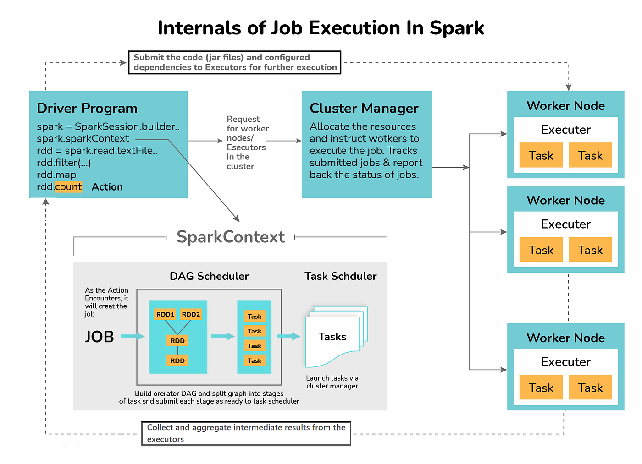

- Write PySpark code to calculate the total sales for each product category.

- Write PySpark code to perform a left join between two DataFrames.
result_df = df1.join(df2, on="id", how="left")
result_df.show()

- Write PySpark code to filter records based on a condition.
filtered_df = df.filter(df.age > 25)
filtered_df.show()

- How to register a User Defined Function (UDF) in PySpark?
You can define a regular Python function and register it as a UDF using `pyspark.sql.functions.udf`.
For example:
```python
from pyspark.sql.functions import udf
from pyspark.sql.types import IntegerType

def square(x):
return x * x

square_udf = udf(square, IntegerType())
df.withColumn("squared", square_udf(df["value"]))

- File formats
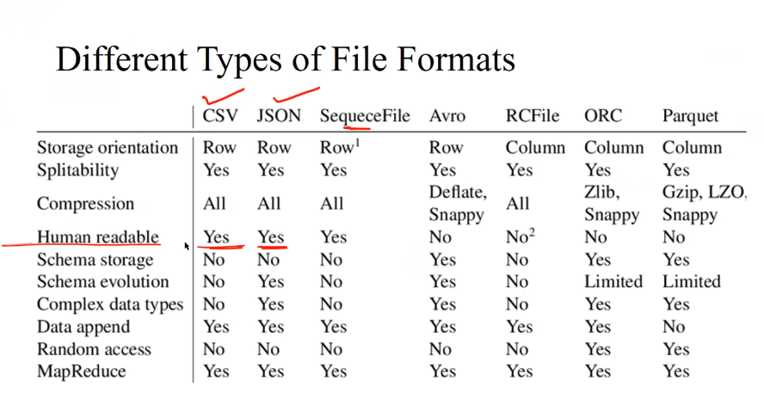
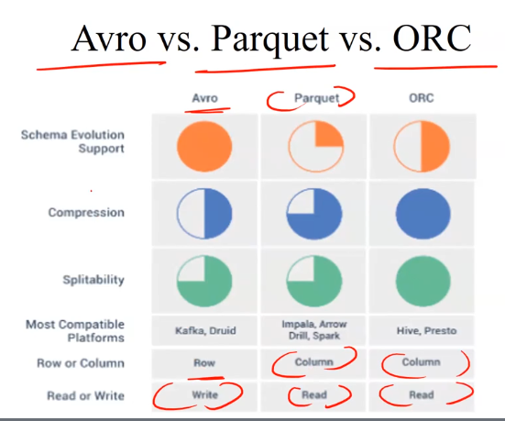

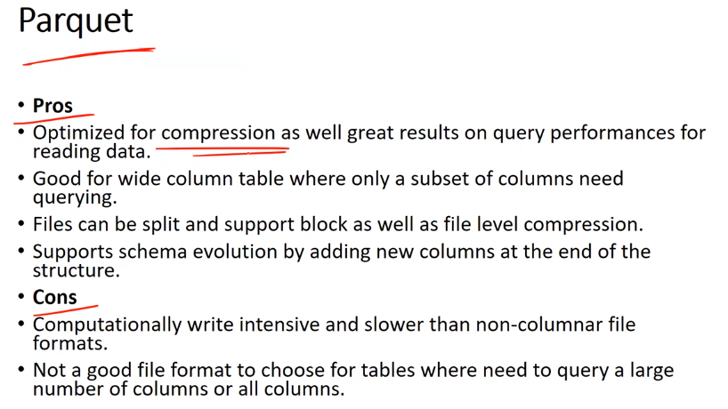

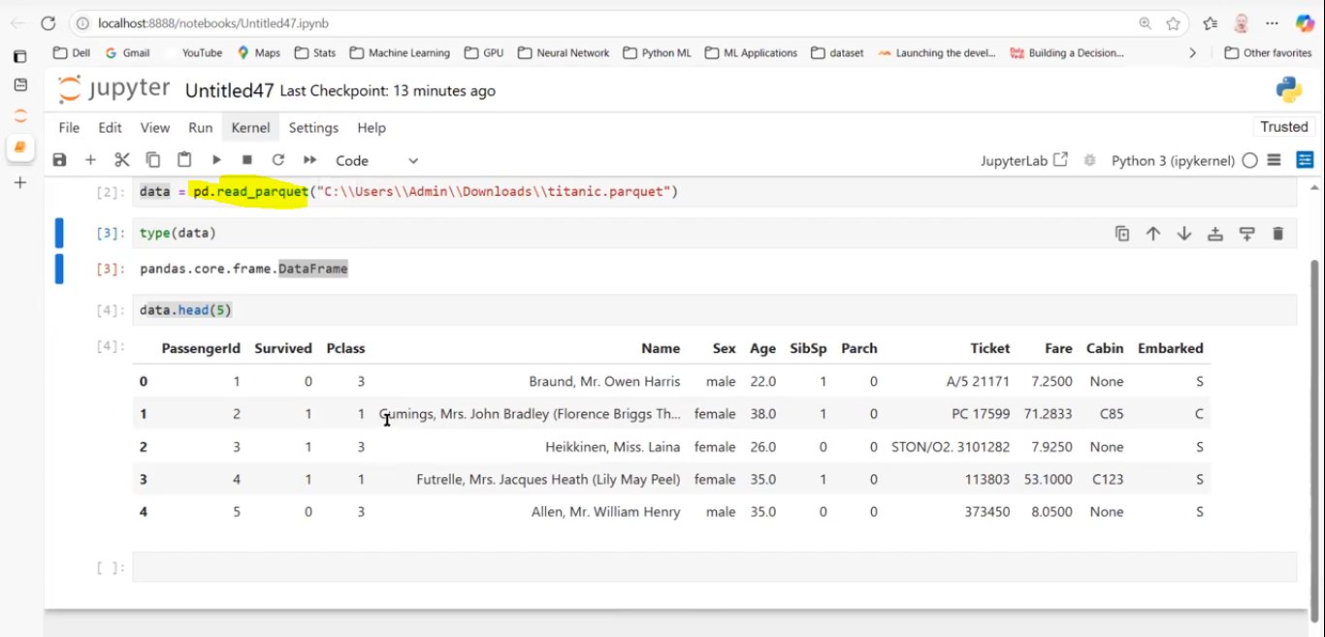

I will be using parquet file format in my project.

- How many jobs, stages, and tasks are created during a Spark job execution?
In Spark:
• Job: Triggered by an action (e.g., collect, count, save, etc.).
• Stage: A job is divided into stages based on wide transformations (shuffle boundaries).
• Task: A stage is divided into tasks, with each task processing a partition of data.
Example: If a Spark job reads data, performs a groupBy, and writes it:
• It could be 1 job,
• Split into 2 stages (before and after the shuffle),
• With N tasks (equal to number of partitions in each stage).

